Samba Recon: Basics
Step 1: Open the lab link to access the Kali machine.
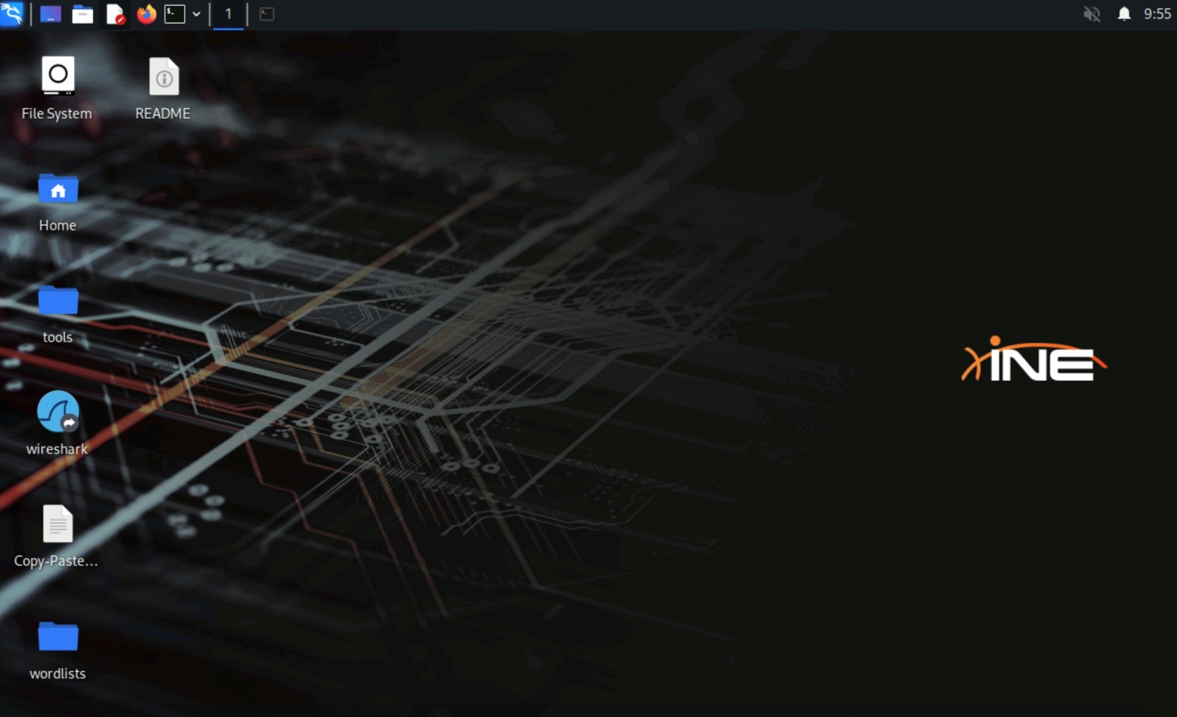
Step 2: Find the default tcp ports used by smbd.
Command:
nmap demo.ine.local
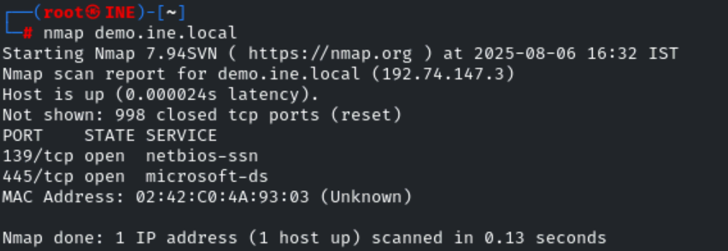
139, 445.
Step 3: Find the default udp ports used by nmbd.
Command:
nmap -sU --top-ports 25 demo.ine.local
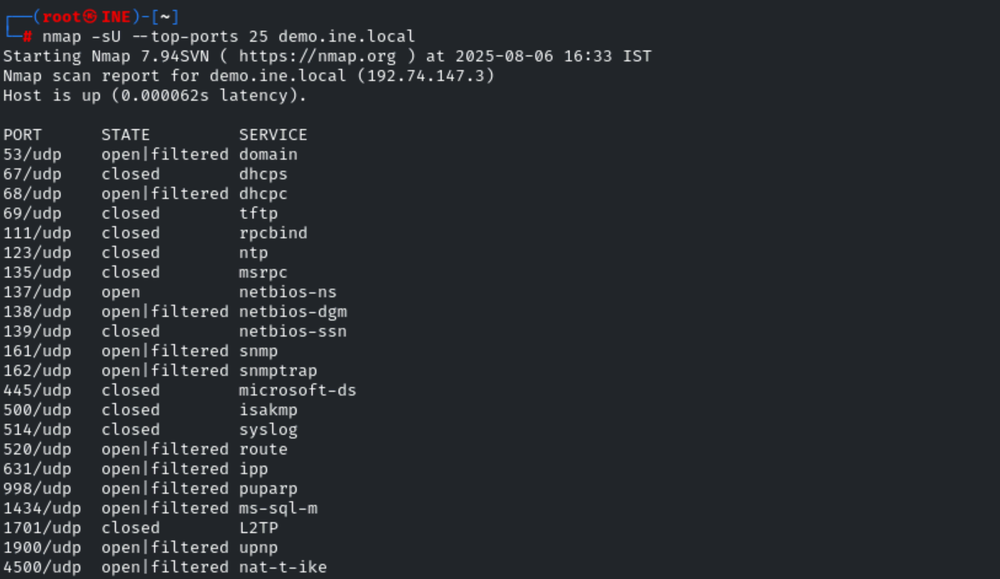
137, 138.
Step 4: What is the workgroup name of samba server?
Command:
nmap -sV -p 445 demo.ine.local
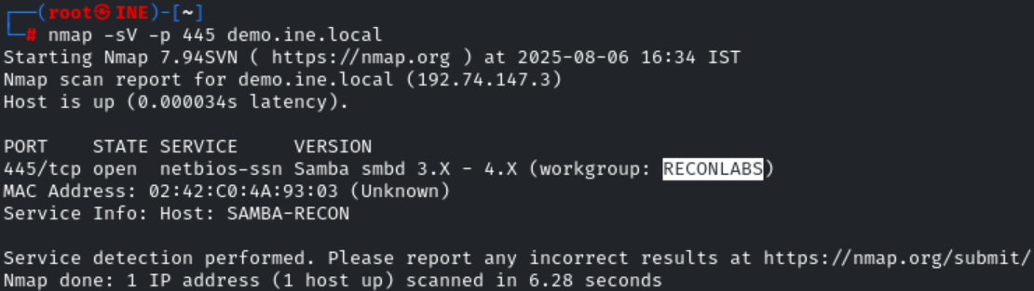
RECONLABS
Step 5: Find the exact version of samba server by using appropriate nmap script.
Command:
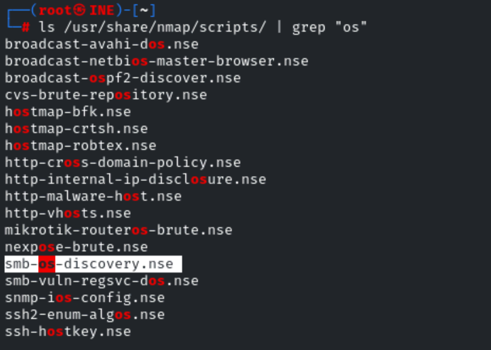
nmap --script smb-os-discovery.nse -p 445 demo.ine.local
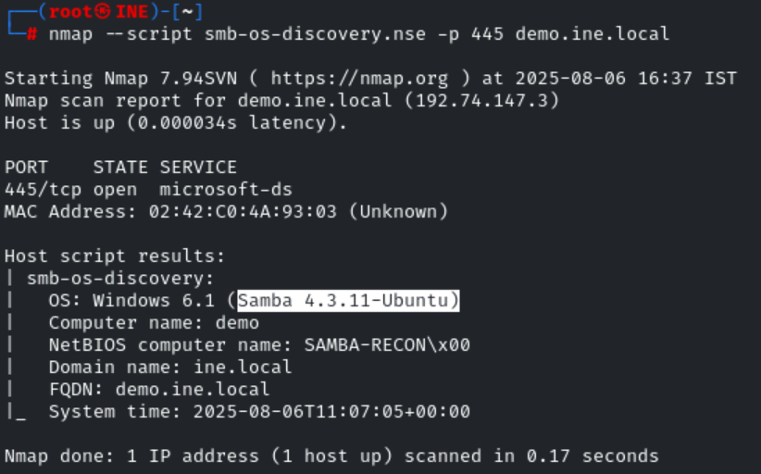
Samba 4.3.11-Ubuntu
Step 6: Find the exact version of samba server by using smb_version metasploit module.
Commands:
msfconsole -q
use auxiliary/scanner/smb/smb_version
set RHOSTS demo.ine.local
exploit

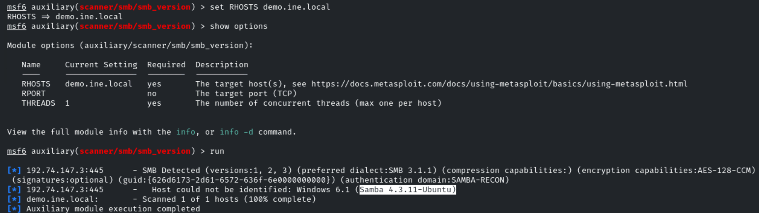
Samba 4.3.11-Ubuntu
Step 7: What is the NetBIOS computer name of samba server? Use appropriate nmap scripts.
Command:
nmap --script smb-os-discovery.nse -p 445 demo.ine.local
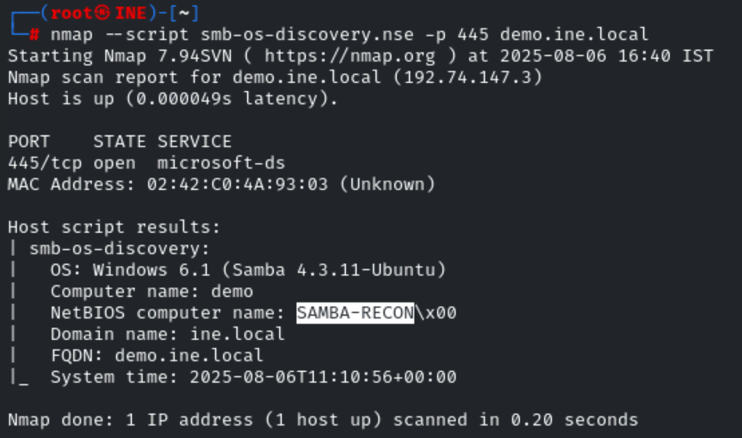
SAMBA-RECON
Step 8: Find the NetBIOS computer name of samba server using nmblookup.
Command:
nmblookup -A demo.ine.local
Explanation:
- nmblookup: A tool to query NetBIOS names on a network (used with SMB).
- -A: Tells nmblookup to perform a lookup by IP or hostname (not by NetBIOS name).
- demo.ine.local: The target hostname (can also be an IP).

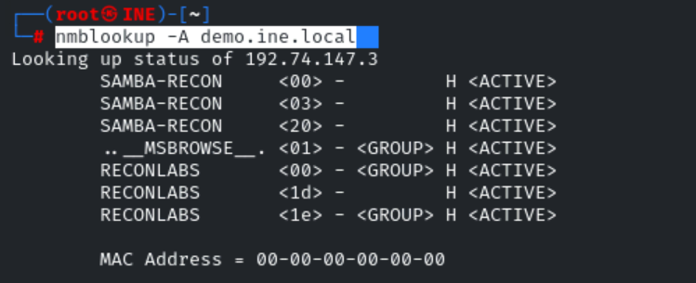
SAMBA-RECON
Step 9: Using smbclient determine whether anonymous connection (null session) is allowed on the samba server or not.
Command:
smbclient -L demo.ine.local -N
Explanation:
- smbclient: Linux command-line tool to interact with SMB (Windows file sharing) servers.
- -L demo.ine.local: Lists all available shared resources (shares) on the server demo.ine.local.
- -N: Tells it to not prompt for a password (tries anonymous login).
Anonymous connection is allowed since shares are displayed without requirement of password.
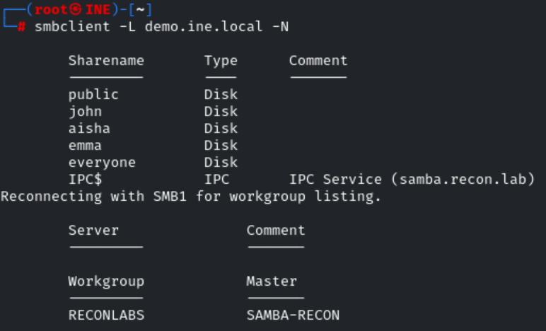
Allowed.
Step 10: Using rpcclient determine whether anonymous connection (null session) is allowed on the samba server or not.
Command:
rpcclient -U "" -N demo.ine.local
Explanation:
- rpcclient: A tool to interact with Windows RPC services (over SMB).
- -U "": Uses an empty username (anonymous login).
- -N: Skips password prompt (null password).
- demo.ine.local: Target hostname or IP.
Anonymous connection is allowed since no errors are thrown while connecting to samba serverwithout any credentials.
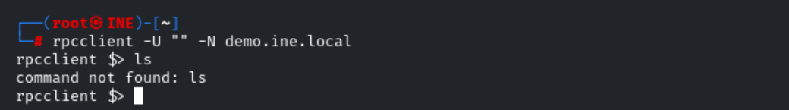
Allowed.
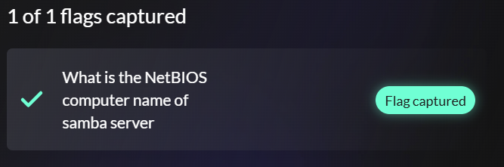
SAMBA-RECON

